EE211 Spring 2024
Homework - Problem Set #5

Due: Nov 26th, 11:59 pm
Please scan your homework and upload it on the KLMS website.

Problem 1 (10 points)
Explain qualitatively why a pulse of excess electrons and holes would move together in the presence of an applied electric field.

<Solution>
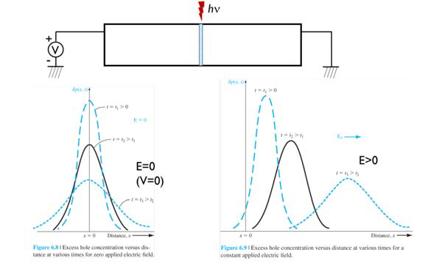
With charge neutrality, δn = δp at any instant of time and at any point in space. The excess electron concentration is equal to the excess hole concentration. Thus, the excess electron pulse is moving in the same direction as the applied electric field even though the electrons have a negative charge.

Problem 2 (10 points)
GaAs, at T = 300 K, is uniformly doped with acceptor impurity atoms to a concentration of N_{a} = 2×10¹⁶ cm⁻³. Assume an excess carrier lifetime of 5×10⁻⁷s.
- Determine the electron-hole recombination rate if the excess electron concentration is δ_{n} = 5×10¹⁴ cm⁻³.
- Using the results of part (a), what is the lifetime of holes?

<Solution>
$p_{o}=N_{a}=2 × {10}^{16}$ $cm^{-3}$, $n_{0}=\frac{{n_{i}}^{2}}{p_{0}}=\frac{{(1.8 × {10}^{6})}^{2}}{2 ×{10}^{16}}=1.62 × {10}^{-4} cm^{-3}$
$$(a) R'=\frac{δn}{τ_{no}}=\frac{5 ×{10}^{14}}{5 ×{10}^{-7}}={10}^{21} cm^{-3}s^{-1}$$
$$(b) R_{p}=\frac{p_{o}}{τ_{pt}}=\frac{n_{o}}{τ_{nt}}=\frac{n_{o}}{τ_{no}}$$
$$τ_{pt}=\frac{p_{o}}{n_{o}}τ_{no}=\frac{2 ×{10}^{16}}{1.62 ×{10}^{-4}}×5 ×{10}^{-7}=6.17 × {10}^{13}s$$

Problem 3 (10 points)
An n-type silicon sample contains a donor concentration of N_{d} = 10¹⁶ cm⁻³. The minority carrier hole lifetime is found to be τ_{p0} = 20 μs.
- What is the lifetime of the majority carrier electrons?
- Determine the thermal-equilibrium generation rate for electrons and holes in this material.
- Determine the thermal-equilibrium recombination rate for electrons and holes in this material.

<Solution>
$(a)$Recombination rates are equal
$$\frac{n_{o}}{τ_{no}}=\frac{p_{o}}{τ_{po}} , n_{o}= N_{d}= {10}^{16} {cm}^{-3}$$
$$p_{o}=\frac{{n_{i}}^{2}}{n_{o}}=\frac{(1.5 ×{{10}^{10})}^{2}}{{10}^{16}}=2.25 × {10}^{4} {cm}^{-3}$$
$$Then \frac{{10}^{16}}{τ_{no}}=\frac{2.25 ×{10}^{4}}{20 ×{10}^{-6}} , τ_{no}=8.89 ×{10}^{6} s$$
$(b)$Generation rate = recombination rate
$$Then G=\frac{2.25 ×{10}^{4}}{20 ×{10}^{-6}}=1.125×{10}^{9} {cm}^{-3}s^{-1}$$
$$(c) R=G= 1.125×{10}^{9} {cm}^{-3}s^{-1}$$

Problem 4 (10 points)
A silicon sample at T = 300 K has a uniform acceptor concentration of 7×10¹⁵ cm⁻³. The excess carrier lifetime is τ_{n0} = 10⁻⁷ s.
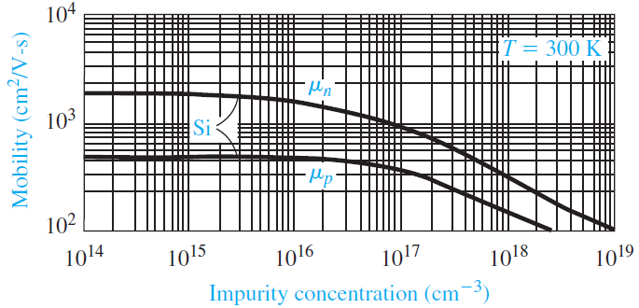
(a) Determine the ambipolar mobility.
(b) Find the ambipolar diffusion coefficient.
(c) What are the electron and hole lifetimes?

<Solution>
p-type material: minority carriers are electrons
$\left(a\right) μ^{'}= μ_{n}$ from figure 5.3, $μ_{n} ≅ 1300 {cm}^{2}/Vs$
$\left(b\right) D^{'}= D_{n} =\left(\frac{kT}{e}\right)μ_{n}=\left(0.0259\right)\left(1300\right)=33.67$ ${cm}^{2}/s$
$\left(c\right) τ_{nt}= τ_{no} ={10}^{-7} s, p_{o}= N_{a} ={7 ×10}^{15} {cm}^{-3}$
$$n_{o}=\frac{{n_{i}}^{2}}{N_{a}}=\frac{(1.5 ×{{10}^{10})}^{2}}{{7 ×10}^{15}}=3.21 × {10}^{4} {cm}^{-3}$$
$$\frac{n_{o}}{τ_{nt}}=\frac{p_{o}}{τ_{pt}}= \frac{{3.214 ×10}^{4}}{{10}^{-7}} = \frac{{7 ×10}^{15}}{τ_{pt}}$$
$$τ_{pt}={2.18 ×10}^{4} s$$

Problem 5 (10 points)
Assume that an n-type semiconductor is uniformly illuminated, producing a uniform excess generation rate g'. Show that in steady state the change in the semiconductor conductivity is given by
$$∆ σ=e(μ_{n}+ μ_{p})τ_{p0}g^{'}$$
(Hint: In steady-state, $δp = g^{'}τ_{p0}$)

<Solution>
$$σ=eμ_{n}n+ eμ_{n}p$$
With excess carriers
$n=n_{o}+ δn$ and $p=p_{o}+ δp$
For an n-type semiconductor, we can write
$$δn= δp$$
Then
$$σ=eμ_{n}\left(n_{o}+ δn\right)+eμ_{p}\left(p_{o}+ δp\right)$$
or
$$σ=eμ_{n}n_{o}+eμ_{p}p_{o}+e\left(μ_{n}+ μ_{p}\right)δp$$
So
$$∆ σ=e\left(μ_{n}+ μ_{p}\right)δp$$
In steady-state,
$$δp = g^{'}τ_{p0}$$
So that
$$∆ σ=e(μ_{n}+ μ_{p})τ_{p0}g^{'}$$

Problem 6 (10 points)
Consider a silicon sample at T = 300 K that is uniformly doped with acceptor impurity atoms at a concentration of N_{a} = 10¹⁶ cm⁻³. At t = 0, a light source is turned on generating excess carriers uniformly throughout the sample at a rate of g’ = 8×10²⁰ cm⁻³ s⁻¹. Assume the minority carrier lifetime is τ_{n0} = 5×10⁻⁷ s, and assume mobility values of μ_{n} = 900 cm² /V-s and μ_{p} = 380 cm² /V-s.
(a) Determine the conductivity of the silicon as a function of time for t₀.
(b) What is the value of conductivity at (i) t = 0 and (ii) t = ꝏ?

<Solution>
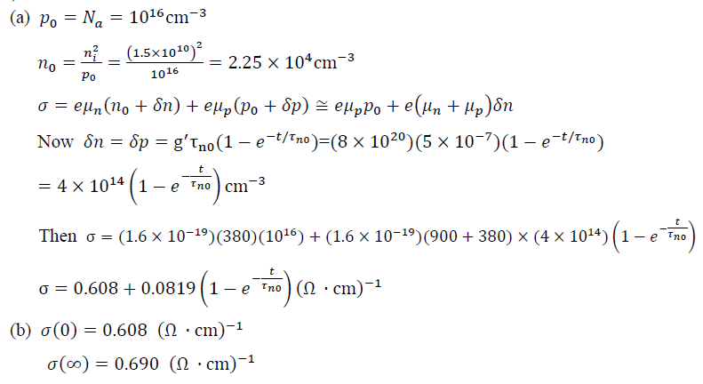

Problem 7 (10 points)
In a GaAs material at T = 300 K, the doping concentrations are N_{d} = 8×10¹⁵ cm⁻³ and N_{a} = 2×10¹⁵ cm⁻³. The thermal equilibrium recombination rate is R_{o} = 4×10⁴ cm⁻³s⁻¹.
- What is the minority carrier lifetime?
- A uniform generation rate for excess carriers results in an excess carrier recombination rate of $R^{'}$= 2×10²¹ cm⁻³ s⁻¹. What is the steady-state excess carrier concentration?
- What is the excess carrier lifetime?

<Solution>
$$n_{o}= N_{d}- N_{a}= {8×10}^{15}- {2×10}^{15}= {6×10}^{15} {cm}^{-3}$$
$$p_{0}=\frac{{n_{i}}^{2}}{n_{0}}=\frac{{\left(1.8 × {10}^{6}\right)}^{2}}{6 ×{10}^{15}}=5.4 × {10}^{-4} cm^{-3}$$
$$\left(a\right) R_{o}=\frac{p_{0}}{τ_{p0}}→ 4 × {10}^{4}= \frac{5.4 × {10}^{-4}}{τ_{p0}}$$
so $τ_{p0}=1.35 × {10}^{-8} s$
$$\left(b\right) δp= g^{'}τ_{p0}=\left(2 × {10}^{21}\right)\left(1.35 × {10}^{-8}\right)=2.7 × {10}^{13} cm^{-3}$$
$$\left(c\right) τ= τ_{p0}=1.35 × {10}^{-8} s$$

Problem 8 (10 points)
Consider a bar of p-type silicon that is uniformly doped to a value of N_{a} = 2×10¹⁶ cm⁻³ at T = 300 K. The applied electric field is zero. A light source is incident on the end of the semiconductor as shown in the figure below. The steady-state concentration of excess carriers generated at x = 0 0 is δ_{p}(0) = δ_{n}(0) = 2×10¹⁴ cm⁻³. Assume the following parameters: μ_{n} = 1200 cm²/V-s, μ_{p} = 400 cm²/V-s, τ_{n0} = 10⁻⁶ s, and τ_{p0} = 5×10⁻⁷ s. Neglecting surface effects,
- Determine the steady-state excess electron and hole concentrations as a function of distance into the semiconductor.
- Calculate the steady-state electron and hole diffusion current densities as a function of distance into the semiconductor.

<Solution>
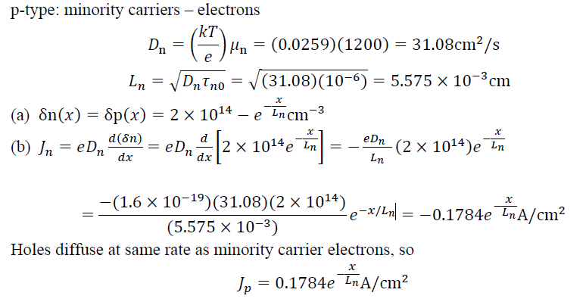

Problem 9 (10 points)
Consider n-type GaAs doped at N_{d} = 10¹⁶ cm⁻³.
(a) For an excess concentration of δ_{p} = (0.02)N_{d}, determine (i) E_{Fn} - E_{Fi} and (ii) E_{Fi} - E_{Fp}.
(b) Repeat part (a) if δ_{p} = (0.1)N_{d}.

<Solution>
$$\left(a\right) \left(i\right) E_{Fn}-E_{Fi}= kTln\left(\frac{n_{o}+n}{n_{i}}\right)= 0.0259ln\left(\frac{1.02 × {10}^{16}}{1.8 × {10}^{6}}\right)=0.58166 eV$$
$\left(ii\right) E_{Fi}-E_{Fp}= kTln\left(\frac{δp}{n_{i}}\right)= 0.0259ln\left(\frac{0.02 × {10}^{16}}{1.8 × {10}^{6}}\right)=0.47982 eV$
$$\left(b\right) \left(i\right) E_{Fn}-E_{Fi}= kTln\left(\frac{n_{o}+n}{n_{i}}\right)= 0.0259ln\left(\frac{1.1 × {10}^{16}}{1.8 × {10}^{6}}\right)=0.58361 eV$$
$\left(ii\right) E_{Fi}-E_{Fp}= kTln\left(\frac{δp}{n_{i}}\right)= 0.0259ln\left(\frac{0.1 × {10}^{16}}{1.8 × {10}^{6}}\right)=0.52151 eV$

Problem 10 (10 points)
Consider p-type silicon at T = 300 K doped to N_{a} = 5×10¹⁴ cm⁻³. Assume excess carriers are present and assume that E_{F} - E_{Fp} = (0.01)kT.
(a) Does this condition correspond to low injection? Why or why not?
(b) Determine E_{Fn} - E_{Fi}.

<Solution>
